Practical Assignment
Real-Time Candidate Status Synchronization
Candidate: Piruthivi P

1. Feature Architecture
1.1 Data flow
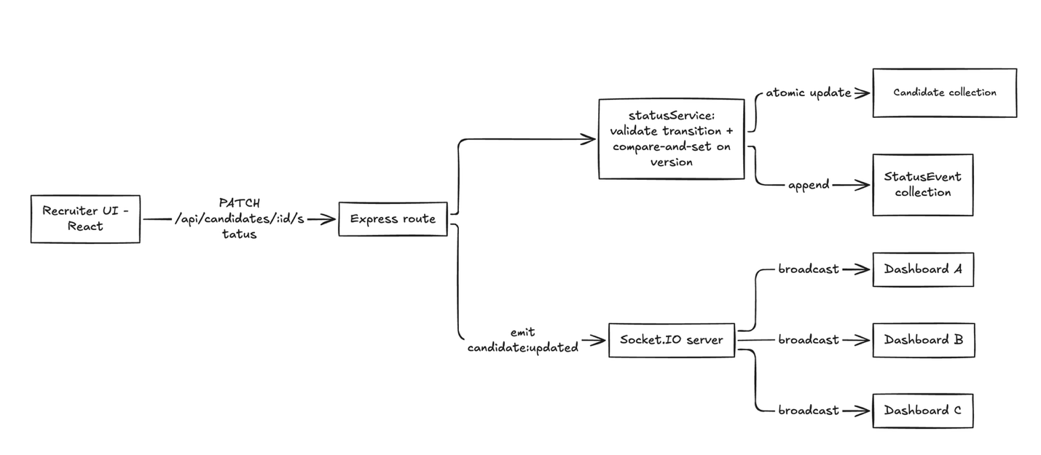
- A recruiter changes a candidate’s status in the React UI.
- The UI sends PATCH /api/candidates/:id/status with the new status and the version it last saw.
- statusService checks the transition is allowed, then runs an atomic compare-and-set on version. A stale version returns 409.
- On success, an append-only StatusEvent is written and the server emits candidate:updated over Socket.IO.
- Every connected dashboard merges the update, ignoring any event whose version is not newer than what it holds.
Design rationale: REST is the only write path, so every change is validated and audited before anyone is notified. Sockets only broadcast, which keeps real-time logic out of business rules.

1.2 Frontend component structure
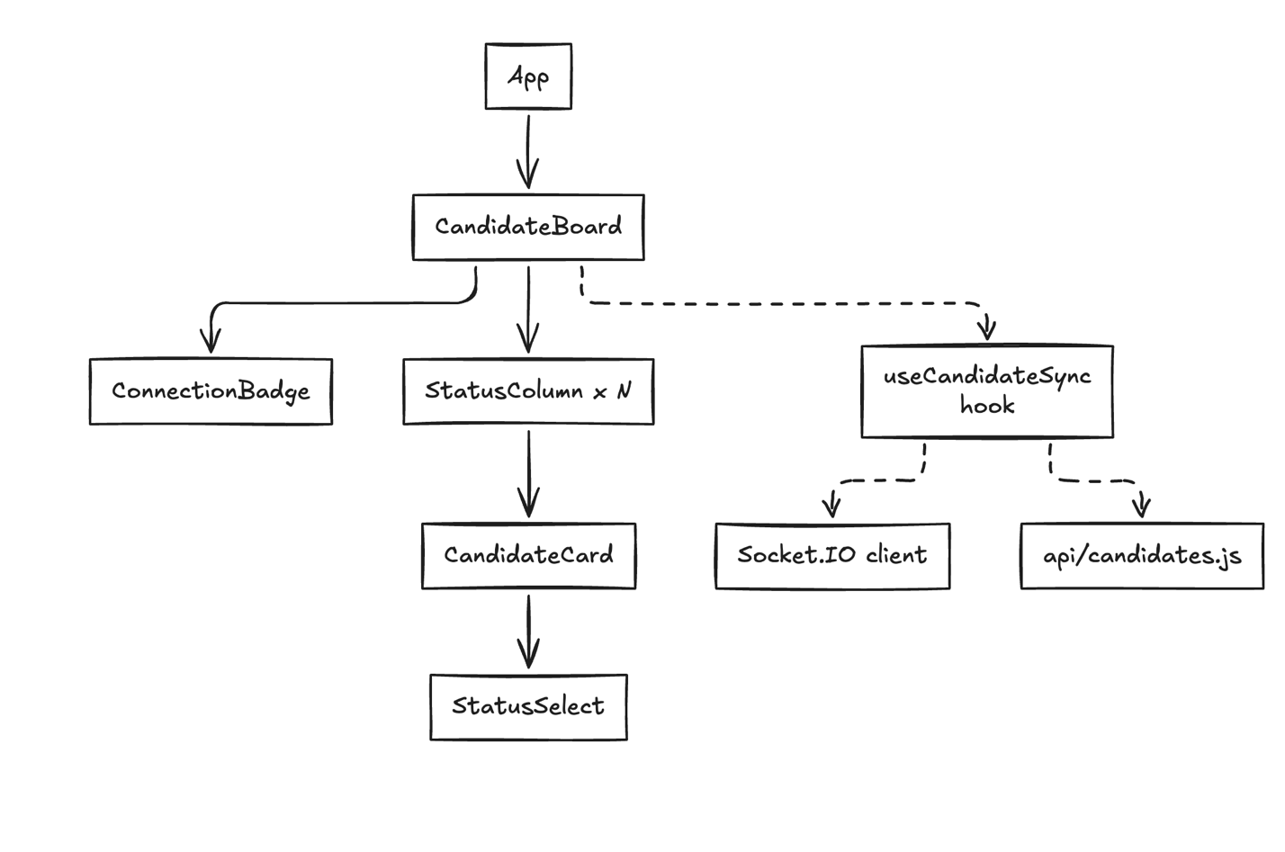
src/
api/candidates.js // fetch wrappers
hooks/useCandidateSync.js // socket subscription, state merge, optimistic update + rollback
components/
CandidateBoard.jsx // owns state via the hook, renders columns
StatusColumn.jsx // one column per status
CandidateCard.jsx // presentational
StatusSelect.jsx // triggers status change, shows errors
ConnectionBadge.jsx // live / reconnecting indicator
Design rationale: all network and socket logic lives in one hook, so components stay presentational and easy to test. The connection badge tells recruiters when the view may be stale.
1.3 Backend structure
server/
index.js // http + Socket.IO bootstrap
models/Candidate.js
models/StatusEvent.js
routes/candidates.js // thin handlers, async error wrapper
services/statusService.js // transition rules, concurrency check, audit write
middleware/errorHandler.js // maps errors to HTTP codes
Design rationale: routes handle HTTP, the service holds business rules, and models hold data shape. Each layer changes independently.
1.4 Database schema (MongoDB)
js
Candidate {
_id,
name: String (required),
email: String (required, unique, lowercase),
role: String (required),
status: enum [applied, screening, assignment, interview, offer, rejected],
version: Number (default 0), // optimistic concurrency token
createdAt, updatedAt
}

StatusEvent { // append-only audit log
_id,
candidateId: ObjectId -> Candidate (indexed),
from: String,
to: String,
changedBy: String,
at: Date
}
Indexes:
- Candidate: { status: 1, updatedAt: -1 } for board queries by column, newest first
- StatusEvent: { candidateId: 1, at: -1 } for a candidate’s history
Design rationale: version lets two recruiters edit at once without locks, because the second write fails cleanly instead of overwriting. Keeping history in a separate collection keeps Candidate documents small and gives a full audit trail.

Section 2 (Implementation)
2.1 Overview
- Backend: Node.js, Express and Mongoose, with Socket.IO for broadcasts. The frontend is React (Vite).
- REST PATCH /api/candidates/:id/status is the only write path. It validates the move, updates atomically, logs the change, then emits candidate:updated.
- A version field gives optimistic concurrency. A stale write returns 409 instead of overwriting.
- A TRANSITIONS map enforces legal stage moves, and illegal ones return 400.
- The client updates the UI optimistically, rolls back on failure, and ignores socket events that are not newer than its local version.
Design rationale: all rules live in one service function, so HTTP, sockets and the UI cannot disagree about what is allowed.
2.2 Key code: atomic status change (server/services/statusService.js)
const TRANSITIONS = {
applied: ['screening', 'rejected'],
screening: ['assignment', 'rejected'],
assignment: ['interview', 'rejected'],
interview: ['offer', 'rejected'],
offer: ['rejected'],

rejected: [],
};

// Only statuses that may legally move to `to`
const allowedFrom = Object.keys(TRANSITIONS).filter((s) => TRANSITIONS[s].includes(to));

// One atomic query: status must be legal AND version must match.
// { new: false } returns the document as it was BEFORE the update.
const before = await Candidate.findOneAndUpdate(
{ _id: id, version: expectedVersion, status: { $in: allowedFrom } },
{ $set: { status: to }, $inc: { version: 1 } },
{ new: false }
);

await StatusEvent.create({ candidateId: id, from: before.status, to, changedBy });
Design rationale: putting the version and the legal-status check in the query filter means the check and the write happen in one step. Two recruiters cannot both succeed, and an illegal move never reaches the database. If the query matches nothing, the service looks up the candidate to decide between 404, 409 and 400.
2.3 Key code: optimistic update and rollback (client/src/hooks/useCandidateSync.js)
const changeStatus = useCallback(
async (id, to) => {
let snapshot = null;

// Optimistic state transition
setCandidates((prev) => {
const target = prev.find((c) => c._id === id);
if (!target) return prev;
snapshot = target; // Synchronous snapshot capture (no stale closure)

return prev.map((c) =>
c._id === id
? {
...c,
status: to,
version: c.version + 1,
updatedAt: new Date().toISOString(),
_isOptimistic: true,
}
: c
);
});

if (!snapshot) return;

// Mark this candidate as pending local update
pendingUpdatesRef.current.add(id);

try {
const serverCandidate = await updateStatus(id, to, snapshot.version, currentUser);

// Success: replace with authoritative document from server
setCandidates((prev) =>
prev.map((c) => (c._id === id ? serverCandidate : c))
);

pendingUpdatesRef.current.delete(id);
return serverCandidate;
} catch (err) {
pendingUpdatesRef.current.delete(id);

// Failure: rollback immediately to pre-update snapshot
setCandidates((prev) =>
prev.map((c) => (c._id === id ? snapshot : c))
);

// Trigger shake animation on the failed card
setRollbackCandidateId(id);
setTimeout(() => setRollbackCandidateId(null), 600);

const errorMessage = err.message || 'Failed to update candidate status';
const isConflict = err.status === 409 || errorMessage.toLowerCase().includes('stale');

setError({
id: Date.now(),
message: errorMessage,
isConflict,
candidateId: id,
candidateName: snapshot.name,
});

throw err;
}
},
[currentUser]
);
Design rationale: the card moves instantly so the UI feels responsive. The previous state is snapshotted first, so a failed request restores it exactly. On success, the server's returned candidate replaces the local copy, so the server stays the source of truth.
2.4 Test results
Jest with mongodb-memory-server: 5 passed, 5 total
- valid transition updates status and increments version
- illegal transition returns 400
- stale version returns 409
- unknown candidate returns 404
- audit log stores the previous status in from
2.5 API behavior (curl)
Valid move (200):
curl -X PATCH http://localhost:5001/api/candidates/<ID>/status \
-H "Content-Type: application/json" -H "x-user: Aisha" \
-d '{"status":"screening","version":0}'
Result: 200 with the updated candidate at version: 1. A connected Socket.IO client received candidate:updated.
Illegal move (400):
-d '{"status":"interview","version":0}'
Result: 400 {"error":"Invalid transition from applied to interview"}
Stale version (409):
-d '{"status":"screening","version":0}' (sent again after the first success)
Result: 409 {"error":"Stale update, refresh and retry"}
Audit history: GET /api/candidates/<ID>/history returned an event with from: "applied", to: "screening" and the recruiter's name.
2.5 Screenshots
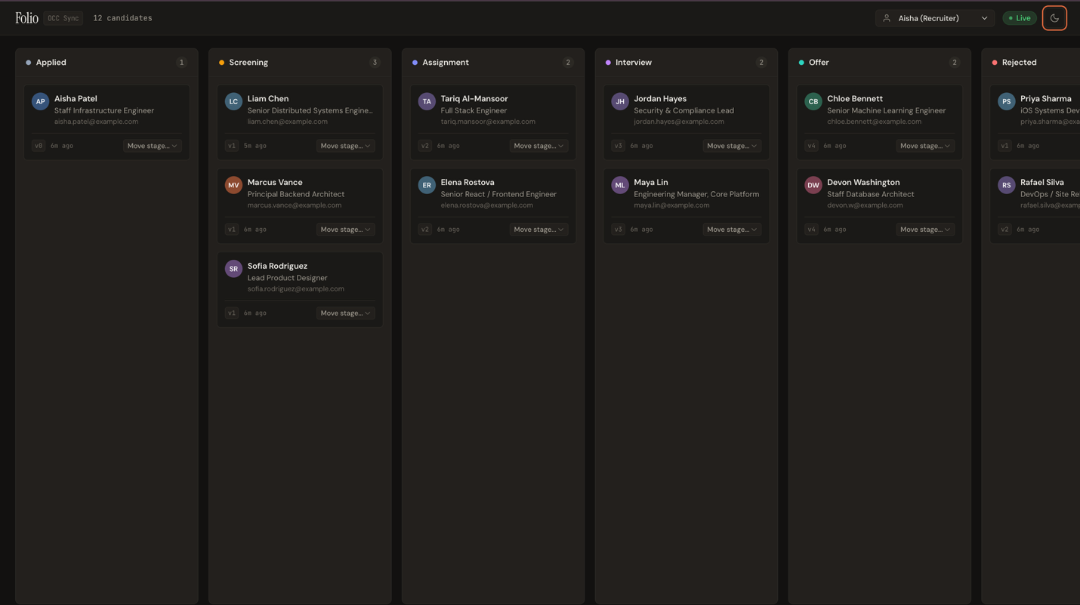
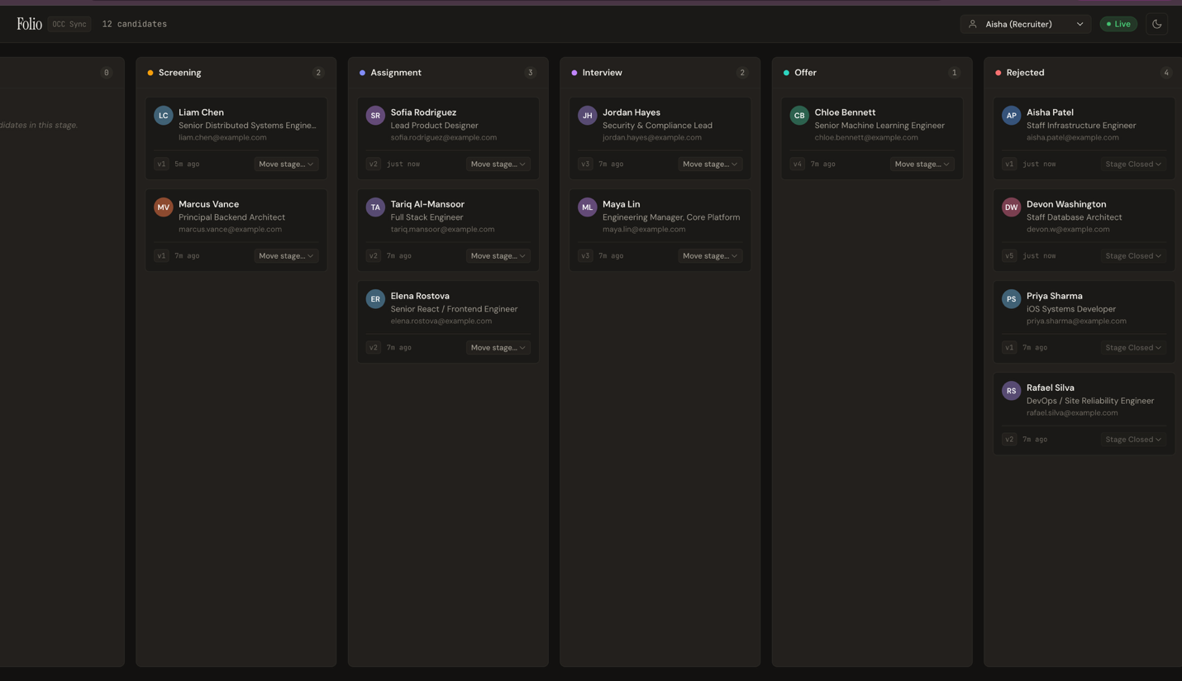
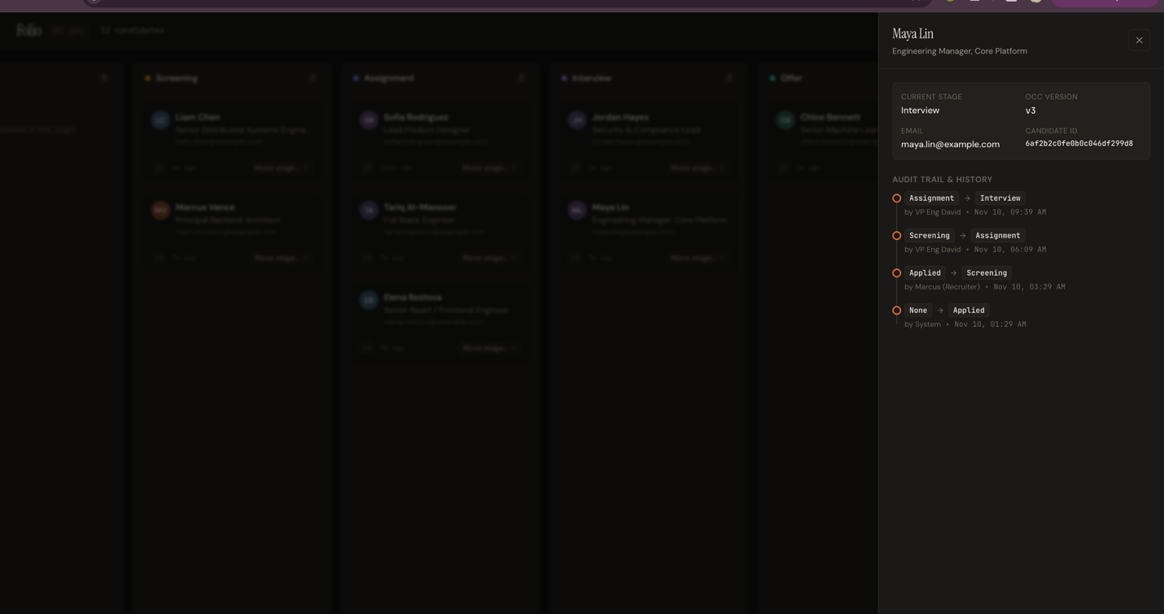

Section 3. Trade-offs and Scalability
- I chose React, Node.js/Express, and MongoDB for full-stack JavaScript consistency, enabling shared validation logic. REST serves as the single write path: state updates are validated, versioned, and logged before Socket.IO broadcasts them, preventing real-time delivery from bypassing business rules.
- MongoDB handles polymorphic candidate fields across roles, while an append-only StatusEvent collection maintains an immutable audit trail. Concurrent edits use optimistic concurrency: atomic version matching succeeds only on current records, throwing clear 409 conflicts instead of silent overwrites.
- To scale horizontally, multiple Node instances run behind a load balancer with the Socket.IO Redis adapter for cross-node event distribution.
- Compound indexes on (status, updatedAt) ensure snappy dashboard queries, and per-role socket rooms minimize unnecessary fan-out.
- If audit volume surges, logging can be offloaded to an asynchronous message queue without blocking the primary transactional path.

